Example code: <https://github.com/jhu-ep-coursera/fullstack-course4>

1.

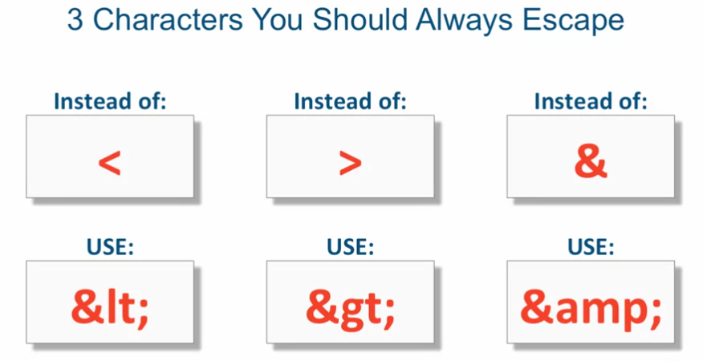

Wrong title h1:



Right one: 

Now it shows:



2. Copy write symbol: &copy;

3. make some word stay together: ‘&nbsp’

4. html qouts : &quot; ‘text’ &quot;

5.

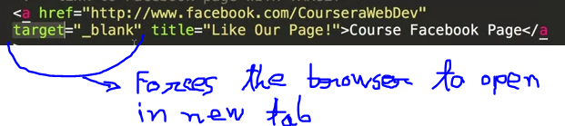

Target =”_blank”

6. fragment identifier, click in a link and it will take to the portion where we want to go:

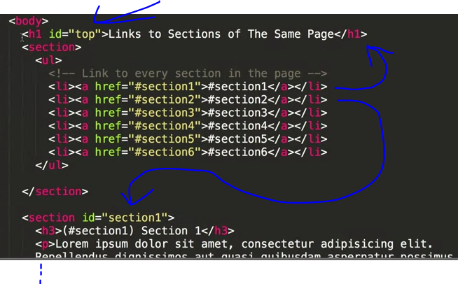

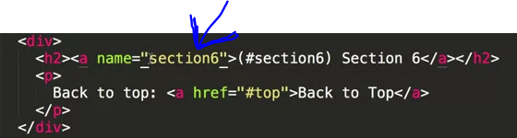

The following code rendering in the middle section of the page allows someone to directly link to that middle section of the page, not just the beginning of the page:

<div id="superInterestingContentHere">Bla Bla</div>

7. CSS selctor:

(a)

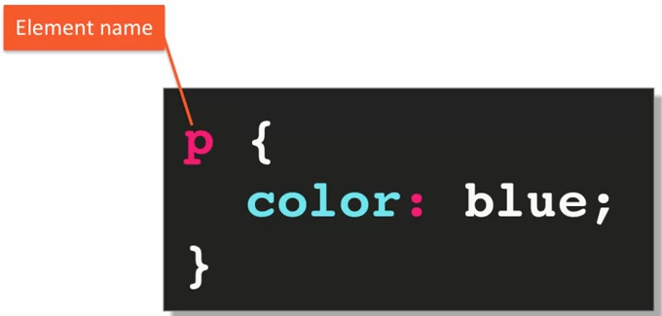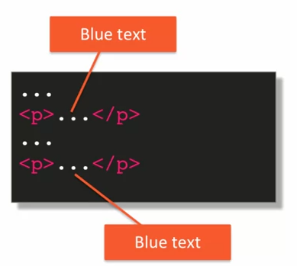

(b)

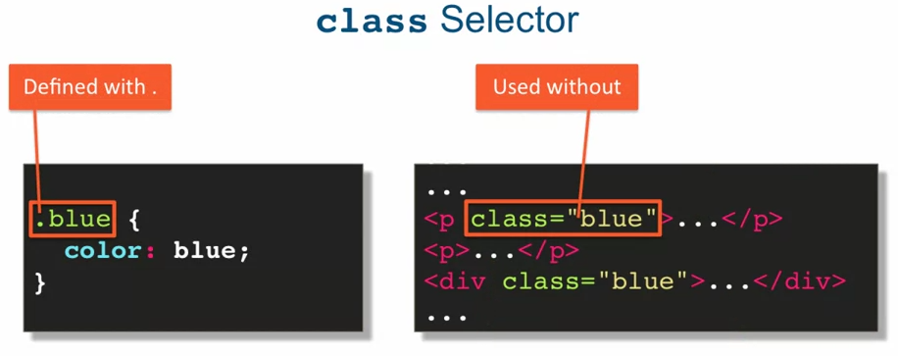

(c)

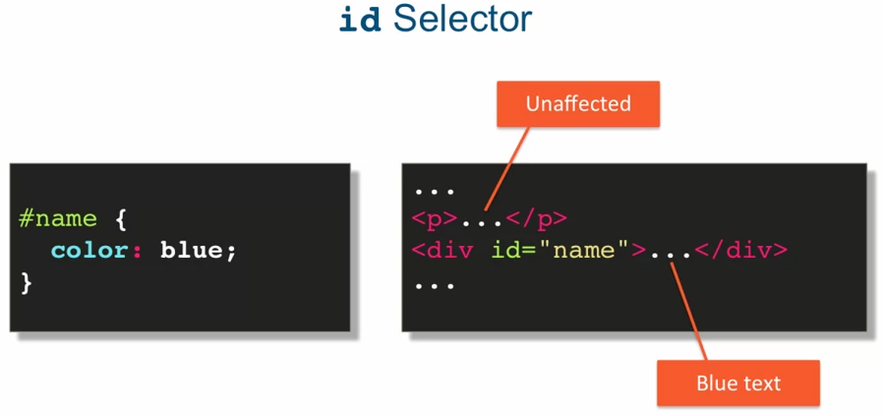

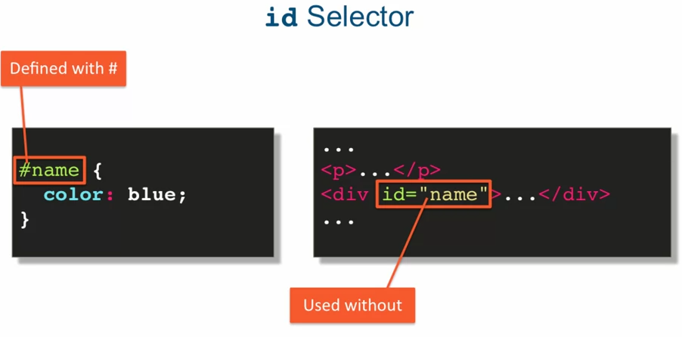

(d)

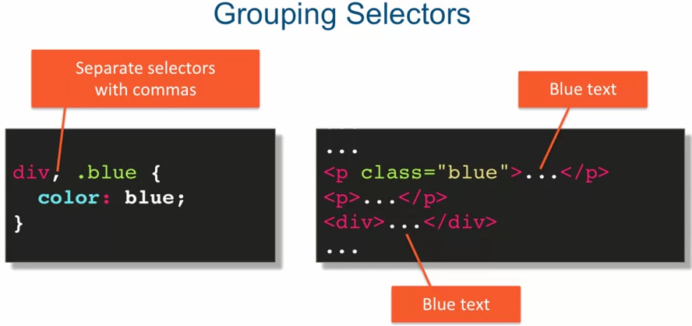

(e) star selector : select every element and apply rules. It could be used to reset all default setting of the browser.

 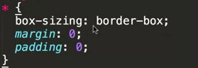

8.

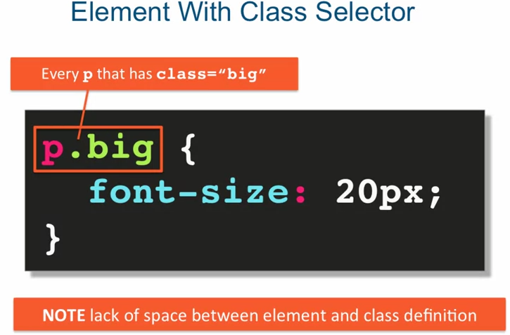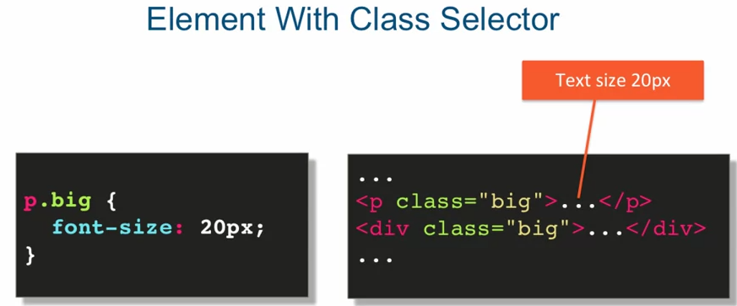

9.

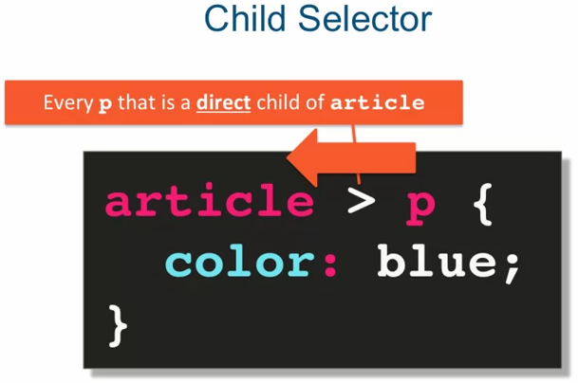

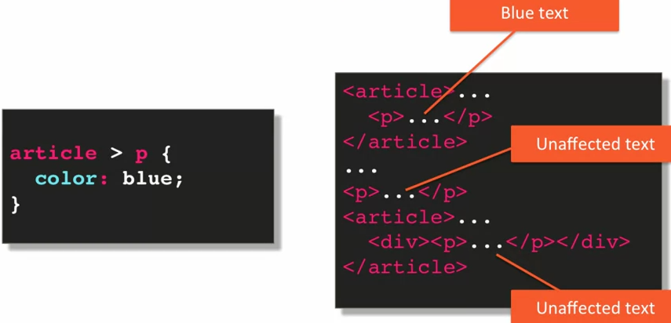

10.

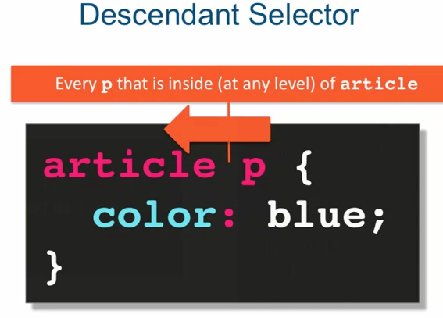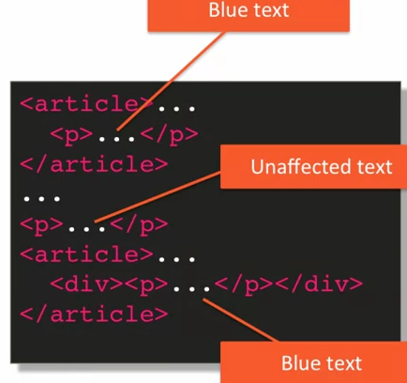

11.

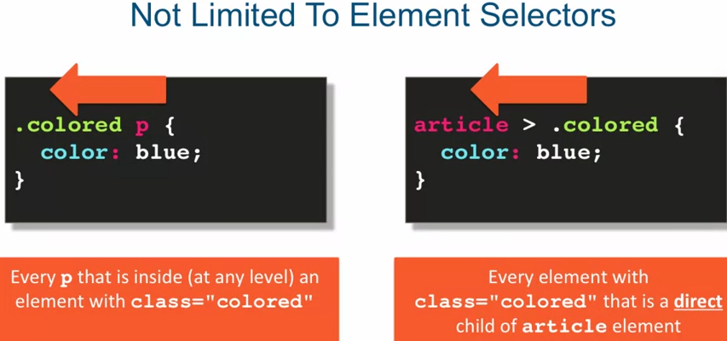

12.

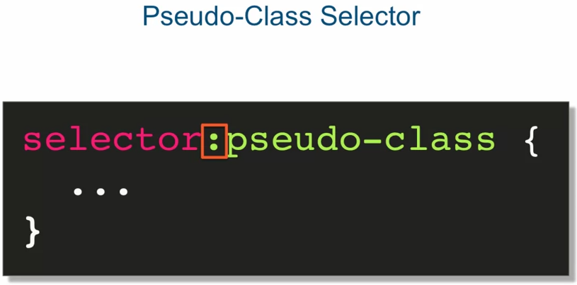

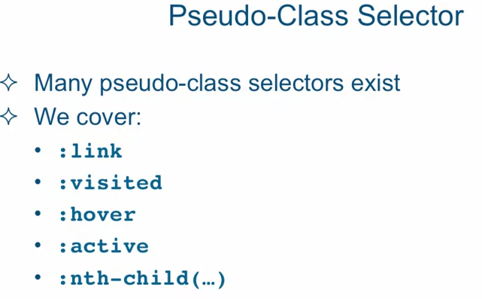

13. for un-order list ‘<ul>’ removie the dot infront of the line : for that css code will be:



li {

list-style:none;

}



14. Remove underline from <a> :



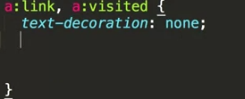



15. modify <a>:



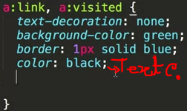



Now add, display: block; 

Add:

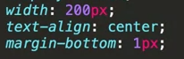 then : 

16. hover interaction:

add: 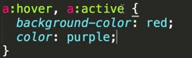 then

17. select a particular item in <ul>:

Example 1 html:

<header>

<ul>

<li><a href="/">Home</a></li>

<li><a href="http://goo.gl/V0Wl6s" target="_blank">AngularJS Course</a></li>

<li><a href="http://www.facebook.com/CourseraWebDev" target="_blank">Facebook Fan Page</a></li>

</ul>

</header>

Here the facebook link in the 3rd <li> , to point that :

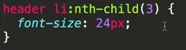

Example 2 html:

<section>

<div>DIV 1</div>

<div>DIV 2</div>

<div>DIV 3</div>

<div>DIV 4</div>

<div>DIV 5</div>

<div>DIV 6</div>

<div>DIV 7</div>

<div>DIV 8</div>

<div>DIV 9</div>

<div>DIV 10</div>

<div>DIV 11</div>

<div>DIV 12</div>

<div>DIV 13</div>

<div>DIV 14</div>

<div>DIV 15</div>

<div>DIV 16</div>

<div>DIV 17</div>

<div>DIV 18</div>

<div>DIV 19</div>

<div>DIV 20</div>

</section>

Here we want to make different color for every odd number <div> :



beside that we also want to make the 4th div element ‘hover color’:

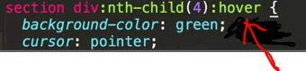when we keep the mouse point on the 4th div then it will turn into green.

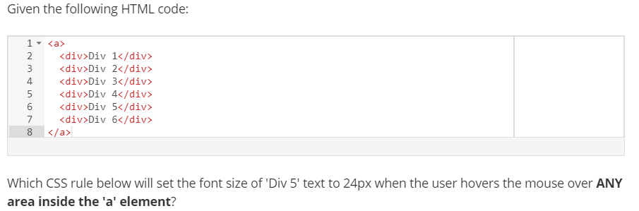



18. link the css file with html file:



19. ‘font family’ is used to have different type of text font for the web site:

Check: <https://www.w3schools.com/cssref/css_websafe_fonts.asp>

20. text customization :

Font-weight:; (bold,900,800,700,300 ,etc)

font-size: 24px; (120%,100%) here if we use 2en , it means : 2 * present font size.

Default font size is 60 . 120% means (60 *(120/100)) =90.

text-transform: uppercase;

text-align: right;

21.

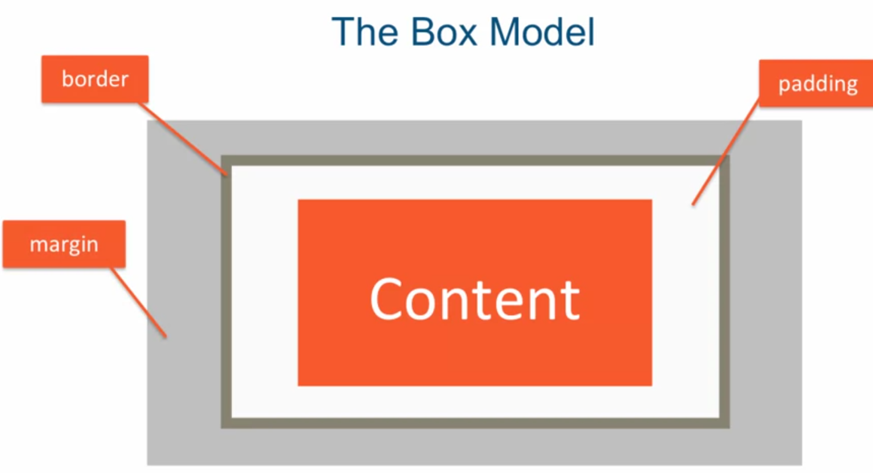

22. add scroll bar in a box: css:

overflow : auto;

23. Set Background color and image:

Css: 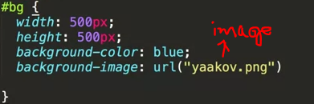html: 